N.V. Sandeep Kumar

192372026

MODULE 1 :-

CREATE TABLE:

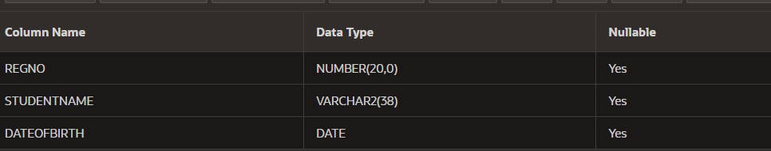

ADD COLUMN:

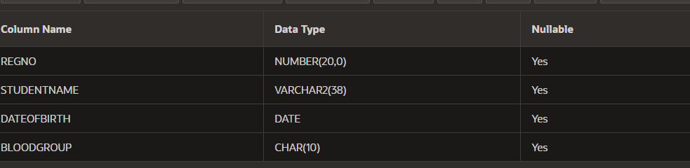

PRIMARY KEY:

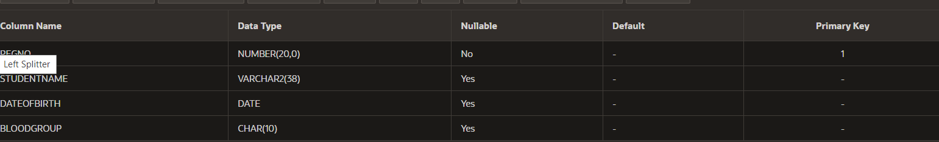

ADD COLUMN:

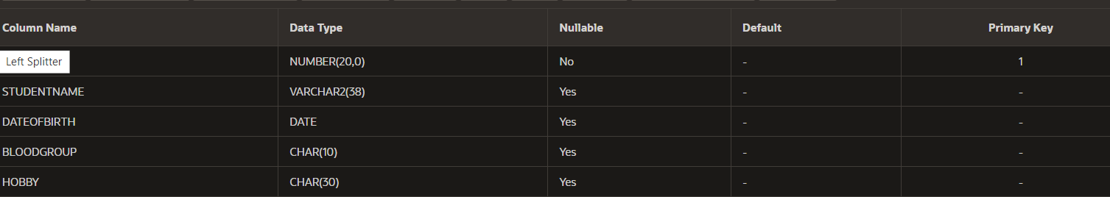

DROP:

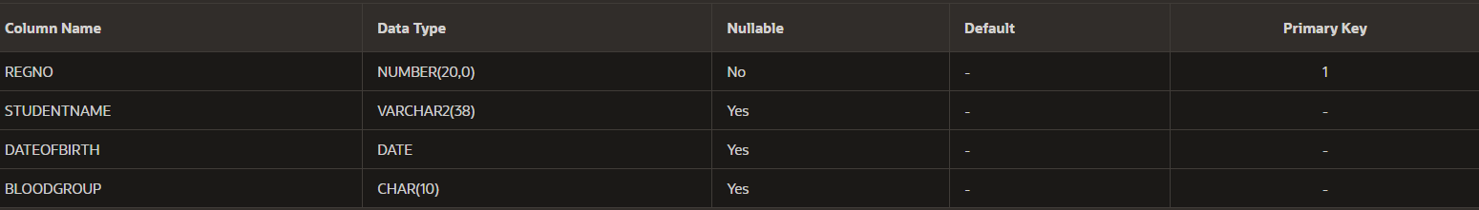

MODIFY:

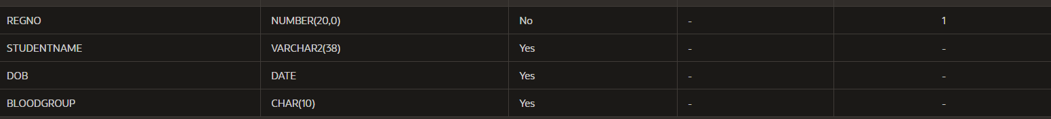

NULL:

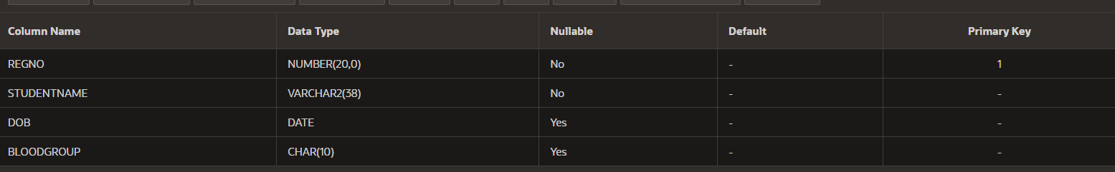

SIZE CHANGE:

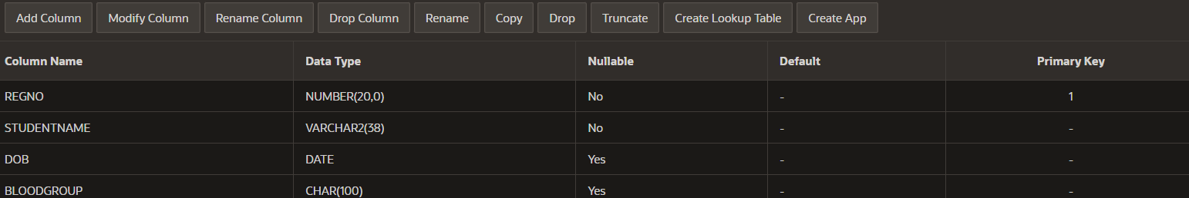

DATATYPE MODIFY:

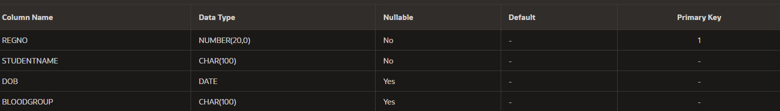

INSERT VALUES:



INSERTING MULTIPLE VALUES FOR ROWS:

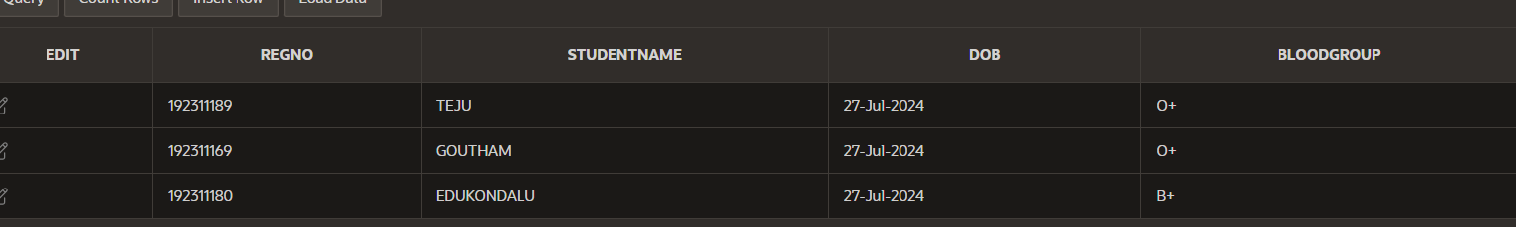

DELETE A ROW:

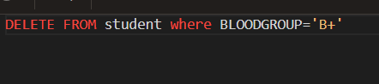

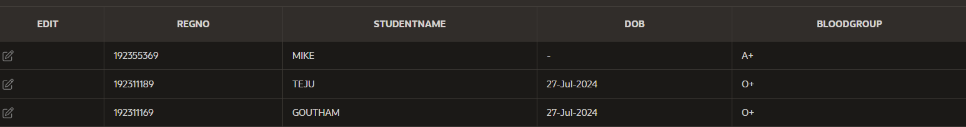

DELETE ALL THE DATA FROM TABLE:

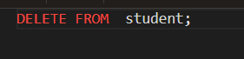

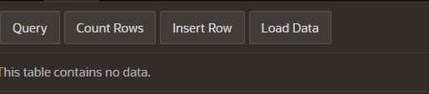

DROP ALL THE TABLE:

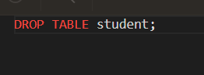

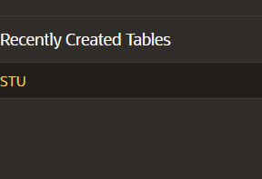

SELECTING ALL ROWS AND COLUMNS FROM TABLE:





Selecting a single row:

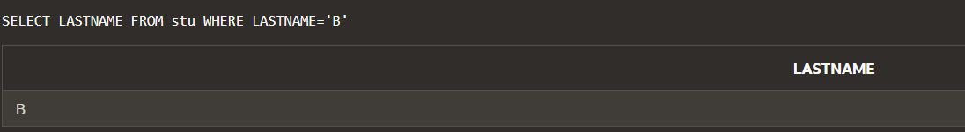

Select marks as studentmarks:



Select using “||”:

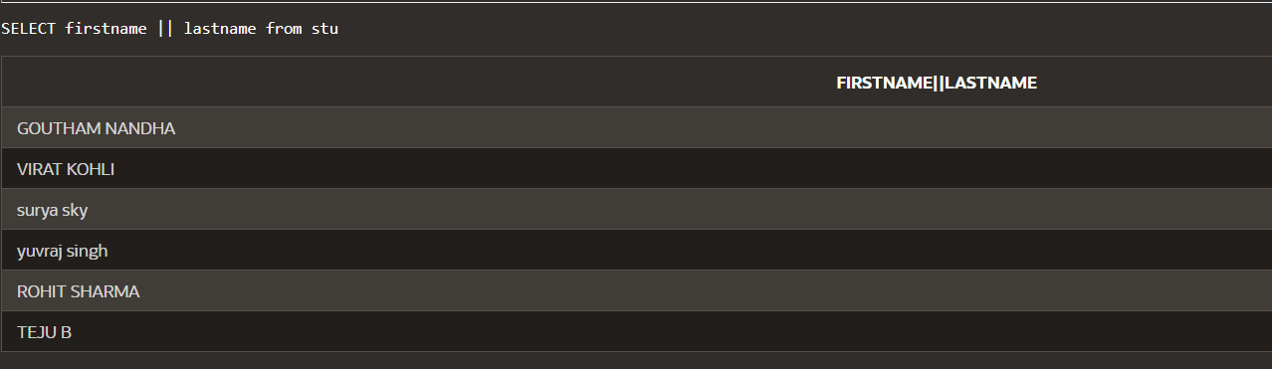

Select using “||” and AS:

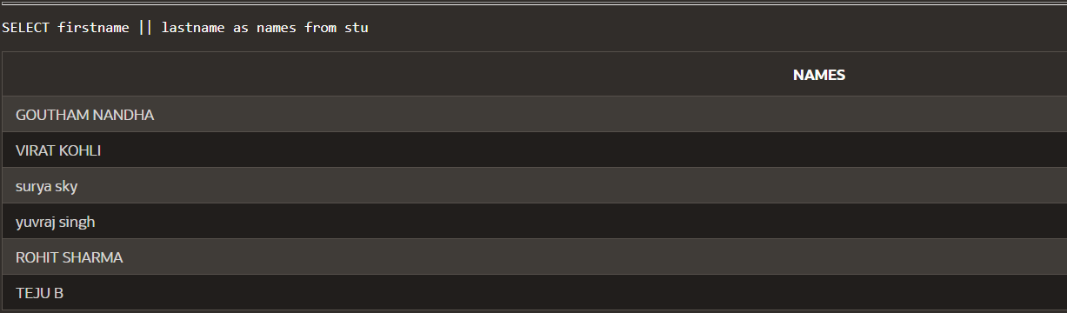

AND OPERATOR:

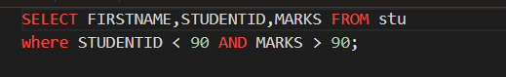

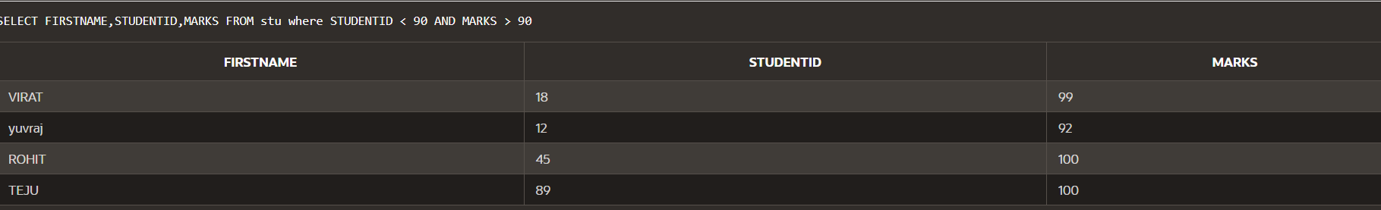

OR OPERATOR:

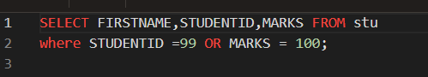

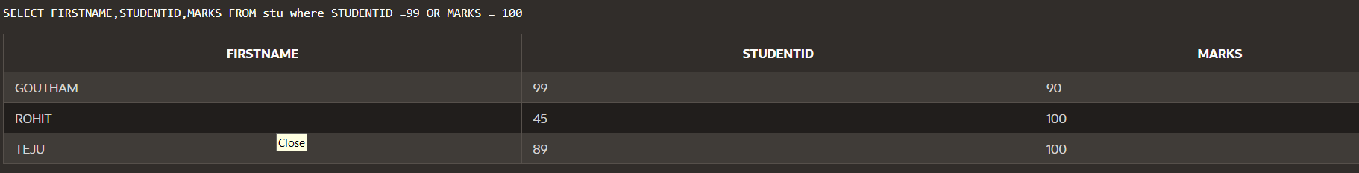

SORTING:

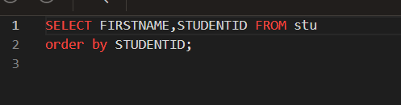

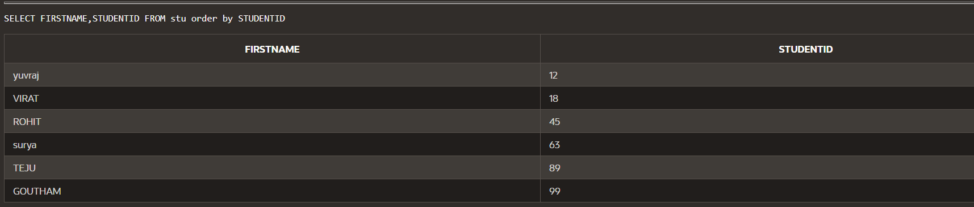

DESCENDIND ORDER:

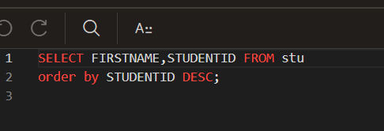

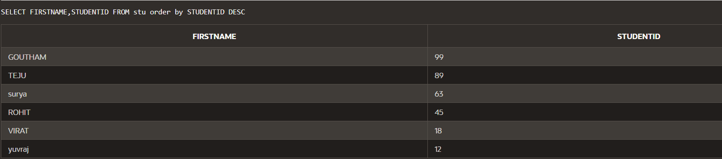

Conditional expressions:

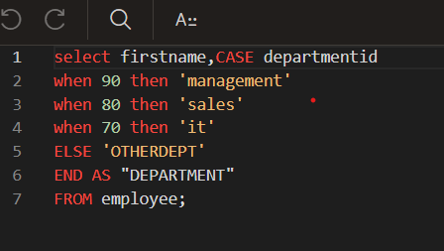

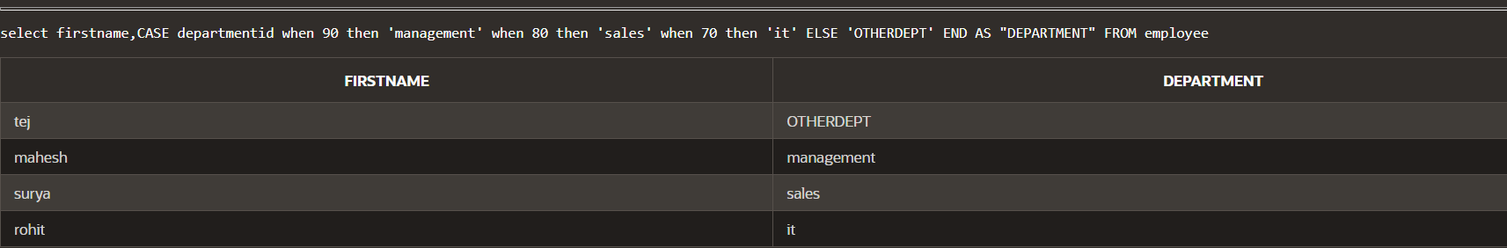

DECODE:

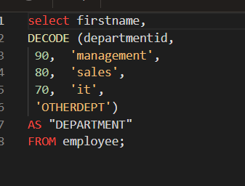

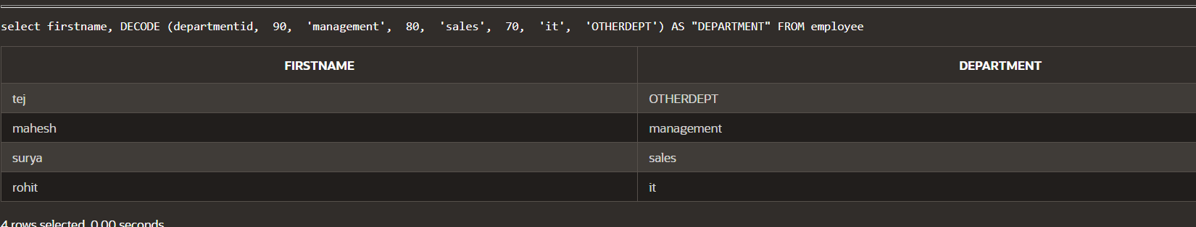

USING CLAUSE:

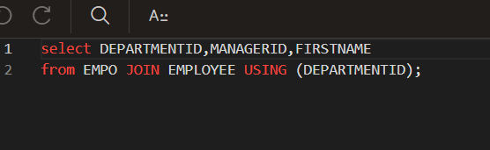



Left outer join:

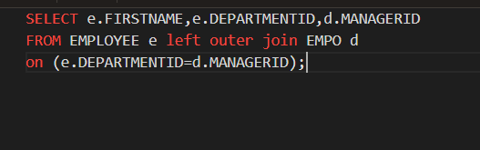

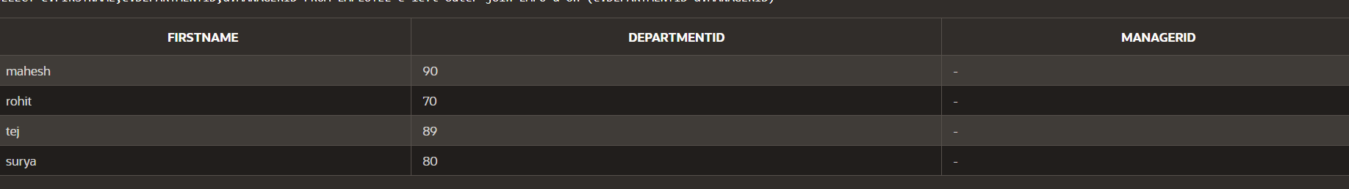

Right outer join:

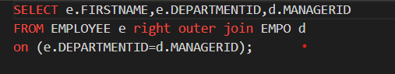

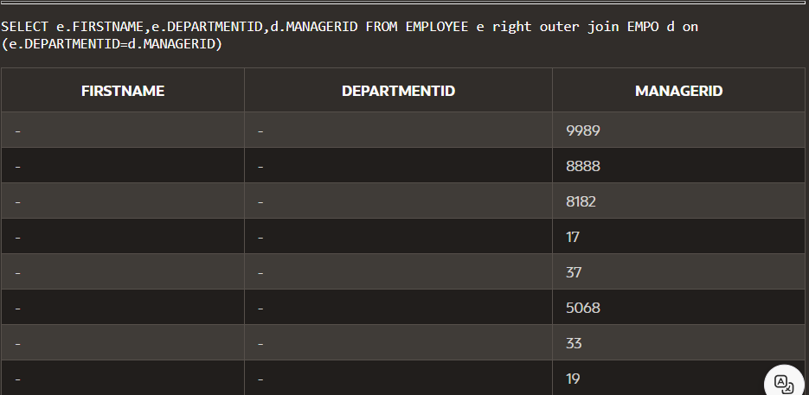

Select join :

